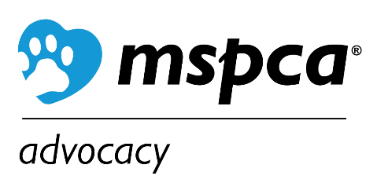

Beaver Funding Assistance Request

Thanks to a grant from the Nion Robert Thieriot Foundation, the MSPCA has funding to assist with installation of water flow devices to humanely, non-lethally, and ecologically mitigate beaver-related flooding in the Berkshires or Franklin, Hampden, or Hampshire counties.

Who can participate? Any individual, town, business, or organization in Berkshire, Franklin, Hampden, or Hampshire counties.

What are the criteria? A willingness (of all parties involved) to resolve problems non-lethally for the long term, a site that is conducive to flow device usage, and permission of the landowners and the local Conservation Commission to install water flow devices. Some financial investment is required from the property owner. We do not award funding for maintenance plans.

How do I request assistance? After obtaining an estimate for the installation of the beaver flow device, send a description of your conflict site(s) with the estimate, and the limitations of your budget to the MSPCA for consideration.

Funding assistance: The amount of funding offered to each applicant will depend on the number of requests, the amount of each viable request, and the ability of each requester to pay for part of the flow device, or the maintenance contract for the device, themselves.

Deadline: Requests will be accepted throughout 2024 until funding is exhausted.
Requests will be considered in the order in which they are received, but financial need can play a role in some cases when funding is limited.

Send requests or any questions to: Melissa Ekvall at mekvall@mspca.org
You may also mail requests to: MSPCA, Attn: Melissa Ekvall – Advocacy, 350 S. Huntington Ave, Boston, MA, 02130 (mailed requests will take longer to process).

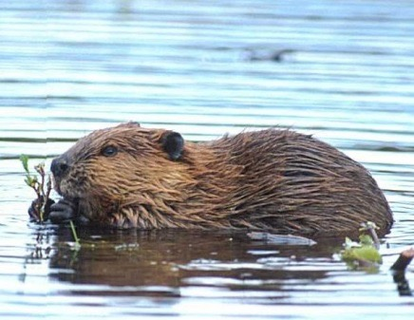
Beaver Funding Assistance Application

Name of applicant(s): _______________________________ Date: ________________________

Address of applicant: _____________________________________________________________________________

Phone: ____________________________ Email: _____________________________________________

Location where device is needed (City/Town, County): __________________________

Type of property in jeopardy due to flooding (home, business, roadway, farm land, etc.):

____________________________________________________________________

Description of site and financial need:

__________________________________________________________________________________________________

__________________________________________________________________________________________________

________________________________________________________________________________________________

__________________________________________________________________________________________________

Total cost estimate of water flow device based on Beaver Solutions Assessment: __________

Property owner contribution: __________

Grant amount requested: __________

Please attach the Beaver Solutions Estimate and any photos taken at the site location to your application email.

