Reconstitution of Amoxi Drops – 30 mL

Your pet was prescribed Amoxi Drops, a liquid oral antibiotic for infections. This medication is good for 14 days after mixing. Your pet may need to continue taking the medication beyond 14 days, so you may be required to mix a second or third bottle at home.
In order to do this, you will need the following:
- Unmixed bottle of Amoxi Drops (30mL)
- 35 mL syringe
- Small cup or bowl
- Plain tap water (cool or room temperature, not warm)
Amoxi Drops come as a powder in a small plastic bottle. Once water has been added to the powder, the medication must be DISCARDED AFTER 14 DAYS. Refrigeration is preferred, but not required.
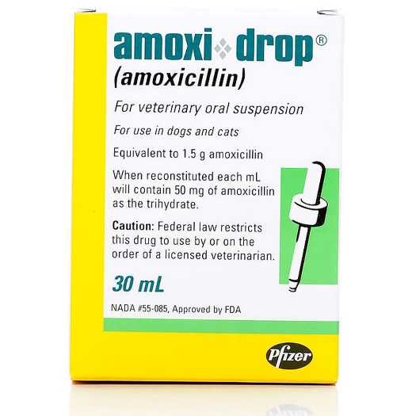
Directions:
1. Carefully remove the plastic cap from bottle.
2. Fill a small cup or bowl with plain water from the tap.
3. Using the syringe provided, insert the syringe tip below the surface of the water in the cup and draw 23 mL of water into the syringe by retracting the plastic plunger. Align the top of the black inner plug (below the cone) with the 23 mL mark.
4. Add the 23 mL of water to the powder in bottle, replace the cap, and shake well.
5. Store mixed medication in the refrigerator or at room temperature, shake before every use, and discard in 14 days.

Please follow your veterinarian’s instructions regarding the amount of medication your pet should receive and how often to administer it. If you have any questions, please do not hesitate to contact us.

