

## Reconstitution of Clavamox Drops

Your pet was prescribed Clavamox Drops, a liquid oral antibiotic for infections. This medication is good for only 10 days after mixing when stored in the refrigerator. Your pet may need to continue taking the medication beyond 10 days, so you may be required to mix a second or third bottle at home.

In order to do this, you will need the following:

* Clavamox powder
* 20 mL syringe
* Small cup or bowl
* Plain tap water (cool or room temperature, not warm)

Clavamox Drops come as a powder in a small plastic bottle. Once water has been added to the powder, the medication must be **REFRIGERATED** and **DISCARDED AFTER 10 DAYS.**

Directions:  
1. Remove the plastic cap and carefully puncture/remove the safety seal foil.

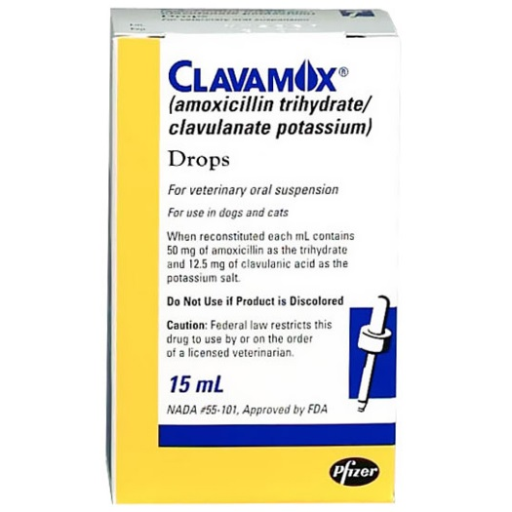2. Fill a small cup or bowl with plain water from the tap.

3. Using the syringe provided, insert the syringe tip below the surface of the water in the cup and draw 14 mL of water into the syringe by retracting the plastic plunger. Align the top of the black inner plug (below the cone) with the 14 mL mark, pictured below.

4. Add the 14 mL of water to the powder in bottle, replace the cap, and shake well.

5. Store mixed medication in the refrigerator, shake before every use, and **discard in 10 days**.



*Please follow your veterinarian’s instructions regarding the amount of medication your pet should receive and how often to administer it. If you have any questions, please do not hesitate to contact us.*