Rectal Administration of Diazepam

Your pet was prescribed Diazepam for seizure control. This medication must be administered rectally.
In order to correctly administer the drug to your pet, you will need the following:
- Vial of injectable Diazepam
- 6mL Syringe
- Needle 19 Gauge
- Catheter (cut to length)

Directions:
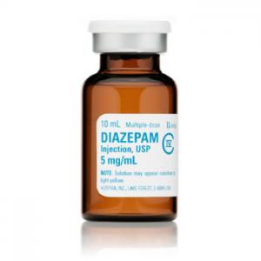
1. Remove plastic cover from top of diazepam vial.
2. Twist needle onto the top of the provided 6mL syringe. Remove clear plastic cap to expose needle.
3. Insert needle through rubber top of vial. Flip vial upside down so that needle is now pointed up. Make sure the tip of the needle is always submerged in the solution.
4. Hold vial and needle together with one hand and with the other, carefully draw the plunger of the syringe down to pull the correct amount of medication into the syringe. Gently tap on side of syringe to release any air bubbles.
5. Remove needle from vial.
6. Place clear plastic cap back on needle and twist to remove needle from syringe. Discard needle in appropriate container.
DO NOT INSERT NEEDLE INTO RECTUM.
7. Replace needle with catheter by firmly pushing wide end of catheter onto syringe tip.
8. Insert narrow end of catheter into pet’s rectum approximately half-way. Inject Diazepam.

Catheters may be washed and reused. Needles and syringes should be placed into Sharps containers and properly disposed of. A new needle and syringe should be used each time.

Please follow your veterinarian’s instructions regarding the amount of medication your pet should receive and how often to administer it. If you have any questions, please do not hesitate to contact us.

