Administration of Inhaled Medications
Your pet was prescribed an inhaled medication for asthma. Some conditions require that medications be given to your pet using an inhaler. An inhaler will deliver the medication directly to the lungs where it is needed.
In order to give your pet their inhaled medication, you will need the following:
- Metered dose inhaler (e.g. Flovent, Proventil)
- Spacing chamber with mask (e.g. Aerokat/Aerodog)

Directions:
1. Prime the inhaler before first use and if inhaler has not been used for more than 2 weeks. To prime the inhaler:
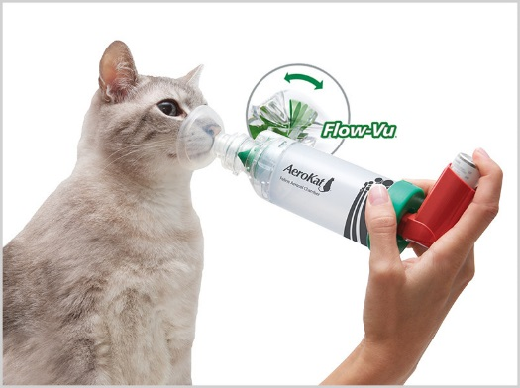
a. Remove the mouthpiece and shake the inhaler well.
b. Point the inhaler into the air and away from the face.
c. Depress the canister to release one spray.
d. Repeat a second time.
2. Attach the mouthpiece of the inhaler to the appropriate end of the spacing chamber.
3. Attach the mask to the other end of the chamber and place over the animal’s nose (pictured).
4. Depress the canister to release the medication into the chamber. Each depression is considered one puff.
5. Allow the pet to breathe normally into the mask for approximately 10 seconds. Ideally, the pet should take at least 5 breaths.
6. Remove the mask from the pet’s nose.
7. Wait 5 to 10 seconds before administering another puff if necessary.
8. Wipe pet’s face with a moist cloth to remove any medication residue.

Please follow your veterinarian’s instructions regarding the amount of medication your pet should receive and how often to administer it. If you have any questions, please do not hesitate to contact us.

