Meropenem Reconstitution Instructions – 1 g Vial

Your pet was prescribed Meropenem, a liquid intravenous antibiotic for infections. This medication is good for 5 days after mixing when stored in the refrigerator and protected from light.
In order to reconstitute this medication, you will need the following:
- Vial of Meropenem (1 gram) powder
- 60 mL Syringe
- Needle 14 Gauge
- NaCl 0.9% solution 100ml bag
- Alcohol swab

Meropenem comes as a powder in a small vial. Once NaCl 0.9% solution has been added to the powder, the medication must be REFRIGERATED and DISCARDED AFTER 5 DAYS.
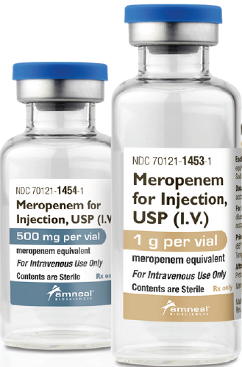
Directions:
1. Remove the protective cap from the Meropenem vial and wipe in one direction with an alcohol swab. Wait for the rubber stopper to dry before puncturing.
2. Twist the needle onto the top of the provided 60mL syringe.
3. Remove and discard 50 mL of NaCl 0.9% solution from a 100 mL bag. Align the top of the black inner plug (below the cone) with the 50 mL mark to measure.
4. From the 50 mL remaining in the NaCl 0.9% bag, draw 25 mL.
5. Inject contents of the syringe into the vial; it will be necessary to withdraw equal amounts of air in between the additions of solution.
6. Shake contents to dissolve and let stand until clear.
7. Draw up the entire amount from the vial and inject back into NaCl 0.9% bag.
8. Administer dose(s) as instructed by veterinarian.
9. Store in the refrigerator between uses.

Please follow your veterinarian’s instructions regarding the amount of medication your pet should receive and how often to administer it. If you have any questions, please do not hesitate to contact us.

