Administering Subcutaneous Fluids
Some medical conditions require animals to receive fluids under the skin. Some commonly prescribed fluids include: Lactated Ringers, Normosol R, and Sodium Chloride.
In order to correctly administer the fluids to your pet, you will need the following:
- Prescribed fluid
- Primary IV set (solution set-up)
- Needles
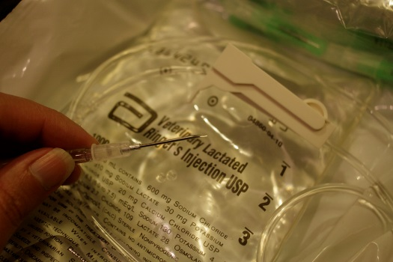
Directions for preparing the fluids:
1. Remove fluid bag and IV set from plastic packaging.
2. Firmly pull white tab from fluid bag to expose opening.
3. Slide regulating clip on tubing of IV set near middle of tubing and roll wheel to tighten clip. Remove plastic cover from spike at the end of IV set.
4. Hold neck of fluid bag with one hand and with the other, firmly insert spike as far as it will go into opening in neck of bag.
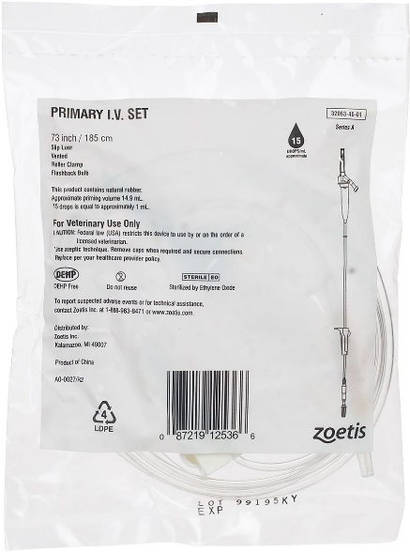
5. Hang fluid bag so that it is higher than the pet. Some find it helpful to hang bag from coat hanger.
6. Gently squeeze clear chamber (at base of spike) of IV set to cause fluid to half-fill chamber. If chamber is too full, fluid will not flow. If this happens, tip bag and chamber upside down to let fluid flow back into bag.
7. Twist off plastic cover from other end of IV set and slide wheel on regulating clip to loosen. Tighten the wheel to stop fluid as soon as fluid drips out of end of line and air bubbles are cleared.
8. Remove colored cap from needle. Insert end of IV set into base of needle, press to tighten, slide plastic ring on tubing over base of needle, and twist to secure.
9. Fluids are now ready to be given.

Directions for administering fluid:
1. Pet should be in a comfortable position on a solid surface.
2. Pinch skin on back, as directed by your veterinarian, to create a pocket. Inject needle parallel to animal’s back (use an across motion, not up and down). Use care to prevent needle from poking through.
3. Loosen wheel on regulating clip to allow fluid to flow. You should see fluid dripping into the chamber.
4. Monitor the amount given using milliliter markings on side of bag.
5. When correct amount is given, tighten the wheel to stop fluid and carefully slide needle out from under pet’s skin (it is normal to see blood).
6. A new needle must be used each time. The IV set may be reused until the bag is replaced. Used needles should be placed in a rigid plastic container and thrown in trash receptacle.
You may also view an instructional video on our webpage at: https://www.mspca.org/pet_resources/how-to-administer-subcutaneous-fluids/

