Beaver Funding
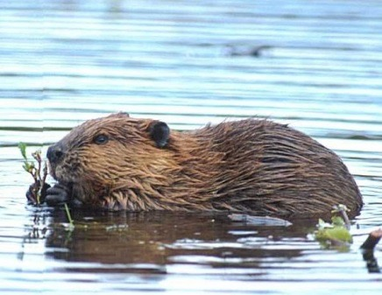
Assistance Request

Thanks to a grant from the Nion Robert Thieriot Foundation, the MSPCA has funding to assist with installation of water flow devices to humanely, non-lethally, and ecologically mitigate beaver-related flooding in the Berkshires or Franklin, Hampden, or Hampshire counties.

Who can participate? Any individual, town, business, or organization
in the Berkshires or Franklin, Hampden, or Hampshire counties.

What are the criteria? A willingness (of all parties involved) to resolve problems non-lethally for the long term, a site that is conducive to flow device usage, and permission of the landowners and the local Conservation Commission to install water flow devices. Some financial investment is required from the property owner.

How do I request assistance? Send a description of your conflict site(s) and the limitations of your budget to the MSPCA for consideration. Starting in the spring, we will evaluate the sites to determine if they are conducive to flow device usage.

Funding assistance: The amount of funding offered to each applicant will depend on the number of requests, the amount of each viable request, and the ability of each requester to pay for part of the flow device, or the maintenance contract for the device, themselves.

Deadline: Requests will be accepted throughout 2018 until funding is exhausted.
Requests will be considered in the order in which they are received, but financial need can play a role in some cases when funding is limited.

Send requests to: Melissa Gallagher, MSPCA, 350 S. Huntington Ave, Boston, MA, 02130, Mgallagher@mspca.org, 617-524-5615, www.mspca.org/beaverfunding
------------------------------------------------------------------------------------------------------------------------------
Please include the following information with requests:

Name: _______________________________ Date: ____________ Town: __________________________

Phone: ____________________________ Email: _____________________________________________

Description of Site: _________________________________________________________________________

Total cost estimate of water flow device: __________

Property owner contribution: __________

Grant amount requested: __________

