2026 MSPCA Bear-Proofing Assistance Program
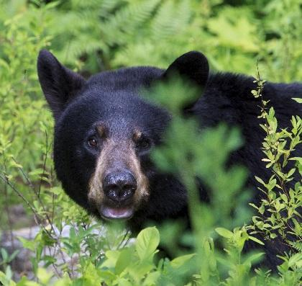

APPLY ONLINE (www.mspca.org/animal_protection/berkshire-bear-proofing-funding/)

OR BY MAIL OR EMAIL (SEE BELOW)

In the Berkshires, conflicts with bears are a serious and frequent problem. Read our tips for mitigating bear conflicts: mspca.org/animal_protection/about-black-bears/). For advice specific to protecting bees and chickens, see: mass.gov/info-details/protect-your-bees-and-chickens-from-black-bears).
Thanks to a grant from the Nion Robert Thieriot Foundation, the MSPCA is able to provide funding assistance for the purchase of bear-proof refuse receptacles in Berkshire County. Interested applicants can apply on the reverse.
WHO IS ELIGIBLE? Any individual or entity in Berkshire County.
WHAT ARE THE CRITERIA? A willingness to resolve problems non-lethally, a site that is conducive to bear-proof refuse receptacle, and permission of property owner to install the receptacle(s).
HOW DO I REQUEST ASSISTANCE? Please fill out the below application. Online is preferred (see above for link), but you can also email or mail a completed application to: mekvall@mspca.org or MSPCA, Attn: Melissa Ekvall, 350 S. Huntington Ave, Boston, MA 02130.
HOW MUCH FUNDING IS AVAILABLE? IS THERE A DEADLINE? Applications are accepted on a rolling basis throughout 2025 until funding is exhausted. Requests will be considered in the order in which they are received, but financial need, the scope of the problem, and what has been tried already to resolve the problem will be taken into account as well. Please note that recipients are generally expected to cover 25%-50% of the cost. Most recipients select something from Bearicuda Bins though this is not required. You can check out their website (bearicuda.com) to get a sense of how much receptacles cost and what options exist. (The Stealth 2 is very popular.)
QUESTIONS? Email or call Melissa Ekvall, at MEkvall@mspca or 617-541-5615

2025 MSPCA Bear-Proofing Assistance Application

Name: ____________________________ Town: _____________________________ Date: _____________________

Phone: ____________________________ Email: ______________________________________________________

Name of organization/business/municipality (if applicable): _________________________________________________

1. How did you hear about this program? ________________________________________________________________

2. Please describe the site and the bear conflict issues. Please send any photos or videos to mekvall@mspca.org.

3. What have you tried so far to mitigate the problem and why do you think these methods haven’t worked?

4. Have you tried waiting until the morning of pick up to put out your trash? Please explain why or why not.

5. Could you commit to finding out if your refuse company works with bear proof receptacles? (Most are.)

6. Could you commit to providing us updates about how the receptacle is working, as well as before and after photos if possible?

7. Anything else you'd like to add? If you have photos or video that you'd like to share please email them to mekvall@mspca.org.

